MedCommons Platform: External Protocols

Version 0.9

Version | Author | Date | Comments
0.1 | SWD |  | Initial Draft
0.2 | SWD | 7/9/04 | Incorporated more protocol details.
0.3 | WLD | 7/19/04 | Cut for external use
0.4 | SWD | 7/19/04 | Added annotations to IHE example
0.5 | WLD | 7/19/04 | Changed footnote structure to alpha to distinguish from IHE use case steps –  Removed indeterminacy where possible
0.6 | WLD | 7/19/04 | Small labeling changes in 2 pictures
0.7 | SWD | 7/21/04 | Made order processing more central and explicit.
0.8 | WLD | 7/23/04 | Preparation for External Distribution  Added MedCommons Network Picture
0.85 | AG | 7/23/04 | Made a few minor changes and clarified the difference between MedCommons and Affiliate’s privacy policies (p. 17).
0.89 | SWD | 7/23/04 | Minor additions on Orders containing Business Orders and CCRs.
0.891 | WLD | 7/23/04 | Upgraded Network Picture  Introduced Collaborative Subnets to the Network Section
0.9 | AG | 7/23/04 | Accepted all changes. We must be done.

The basic purpose of the document is to define the transactions, APIs, and external protocols used by MedCommons. The audience for this document is the management and engineering staff of MedCommons and selected Partners under NDA.

Specific goals of this document
- Provide a consistent naming system for the actors, transactions, and APIs.
- Define the domain of the MedCommons software so that both internal and Affiliate design/coding can occur in parallel.
Software Overview 4
Actors and Transactions of the MedCommons System 6
Objects in the MedCommons Universe 10
Persons 10
MedCommons Orders 10
Documents 11
Nodes 12
Affiliate Interfaces 13
Annotated IHE example 14
10.3 Integration Profile Process Flow 14
Cardiac Patient Management Scenario 14

Network Overview

The MedCommons Network consists of a pair of redundant central sites holding patient and study registries and HIPAA regulatory audit logs, a distributed collection of MedCommons Medical Gateways that reside near Modalities , Storage Repositories and DICOM Workstations, and multiple Affiliate Sites that utilize the MedCommons Network in support of their own independent applications including 2nd Opinions, CAD, and Lifetime Personal Archives.

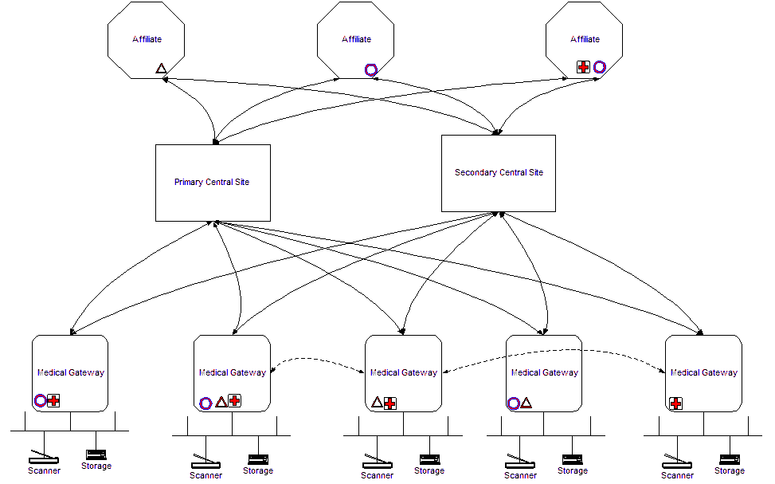

Typically, a user will interact with an Affiliate website which will in turn make a web service call into a MedCommons central site which will subsequently request services from one or more Medical Gateways. However both Medical Gateways and the central sites also offer visual interfaces for appropriately privileged users to allow for control and monitoring of the network, and for directly viewing objects in Storage Repositories.

In addition to the connections between components indicated above, the Medical Gateways will interconnect directly with each other if possible to optimize transfer times between storage repositories. Otherwise, transfers are relayed through one of the central sites.

A Collaborative MedCommons Subnet is a collection of Affiliates and Gateways that have agreed to permit document interchange. MedCommons will not transfer any objects between Gateways that are not part of the same Collaborative MedCommons Subnet. Additional access controls can be applied by Affiliates if desired, but this singular mechanism allows a group of cooperating institutions to immediately establish a useful, secure, and potentially segregated subnetwork without regards. In the picture above, three overlapping subnets are indicated by the O,X,and + symbols.

Software Overview

At a 40,000’ level the organization of the MedCommons software looks like this:

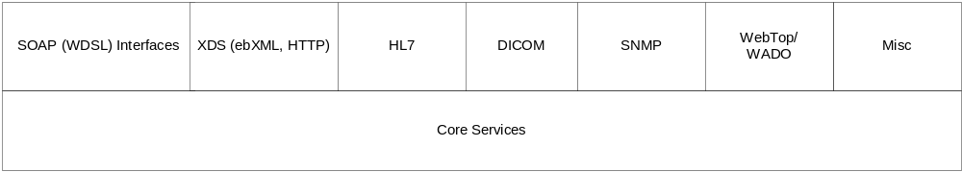

MedCommons consists of a set of core services with different public APIs. In this diagram the gateway and central site software is included in the ‘Core Services’ box.

- The SOAP (WSDL) interfaces provide the bulk of the public API.
- XDS (Cross-Enterprise Document Sharing) is an IHE (Integrating the Healthcare Enterprise) specification for sharing documents between multiple sites and multiple vendors.
- HL7 (Health Level 7) is a medical protocol that is used for many non-image medical transactions: medical orders, patient visits, patient demographic creation/updates, reports, and more.
- DICOM is the protocol by which images are transmitted to MedCommons.
- The core transaction for an Affiliate is the submission of an Order.
- SNMP is used for managing network devices. MedCommons gateways generate SNMP messages for central and other network devices may also be monitored. In a future release of the platform SNMP messages will be exported from MedCommons for external monitoring by off the shelf network management systems.
- WebTop/WADO. This is an HTTP interface for viewing objects within the MedCommons universe. WADO (Web Access to DICOM Objects – DICOM Supplement 85) provides an HTTP mechanism for viewing DICOM objects; MedCommons provides a viewer which organizes the presentation of these objects as well. We expect that other non-DICOM objects [e.g.: CCR (Continuity of Care Record) forms, textual reports, images] will be added to the viewer as part of this framework.
- Misc. include management of users, certificates, configuration, and debugging/logging tools.

The domains of each of these protocols may overlap. As an extreme example consider a radiology report (the radiologist’s billable output from reading a study). A report might arrive over an HL7 socket (old HL7 2.x protocol), via ebXML with either a HL7 2.x or HL7 3.0 (XML) message, or embedded within a DICOM object. Further, enterprising affiliates might capture the radiologist’s report as an audio stream, transcribe it, and then use the SOAP (WDSL) interface for sending it to MedCommons. But the end product in each of these cases is that we have a clinical report from a radiologist that must be viewable in the WebTop/WADO viewer.

As a first guess of who uses what protocols the following diagram presents the current intended use of the platform by various entities:

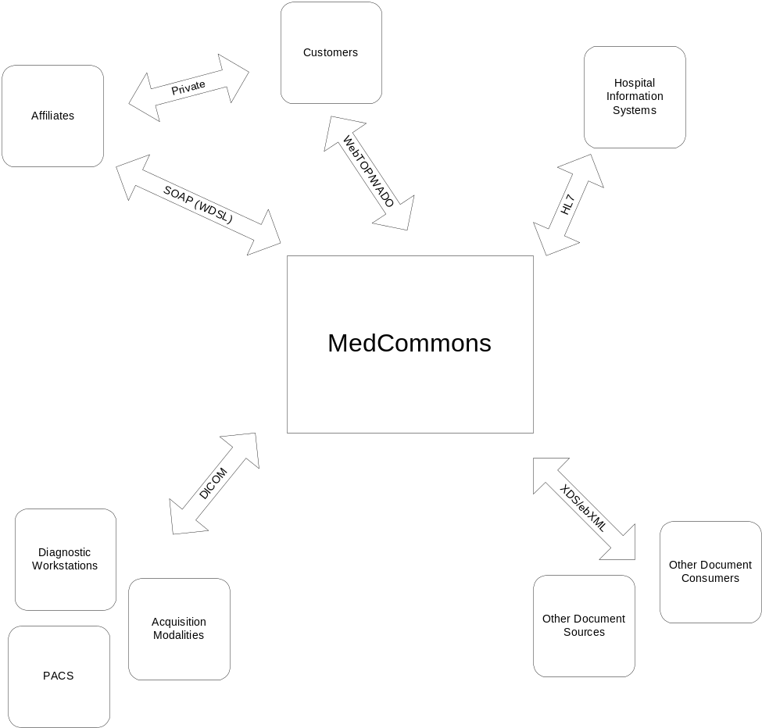

There is still a lot of play here – one could imagine a genomic Affiliate might use XDS directly – but this diagram reflects the platform as currently implemented. Also note the ‘private’ protocol used between a human customer and the Affiliates: we expect the Affiliates to have their own transactions that are not exposed to MedCommons.

Actors and Transactions of the MedCommons System

Actors and transactions are used here to frame the how the system functions. No particular process or module boundaries are intended here. The Document Registry may be handled by multiple processes or it might be in the same process as the Patient Identity Source. The Provisioning actors might be split into multiple actors (one for managing users, another for managing gateways). Also – the IHE actors are also placeholders to some degree: not all transactions for all actors are implemented in the first version of the platform. The purpose of this section is to describe the framework that we need to support IHE; it is also general enough for non-IHE actors and transactions to be added.

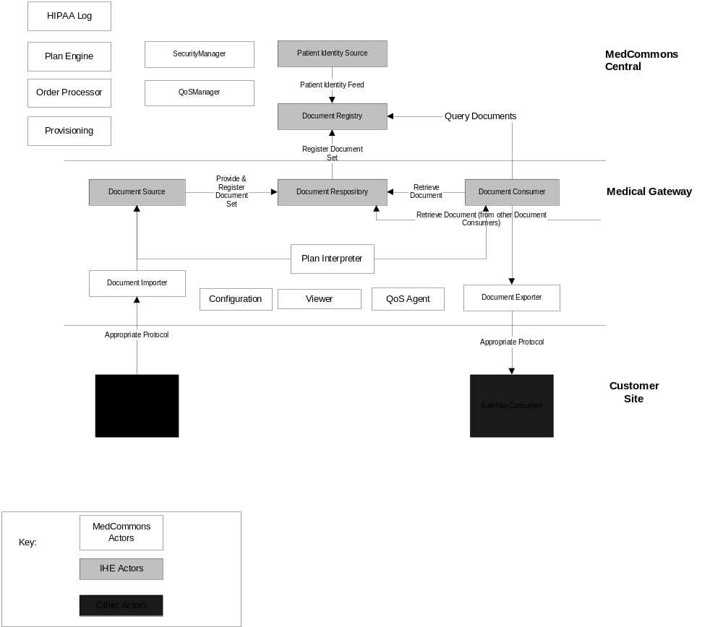
Figure 1: Actors in the MedCommons System: General Pattern
[Only IHE XDS transactions shown]

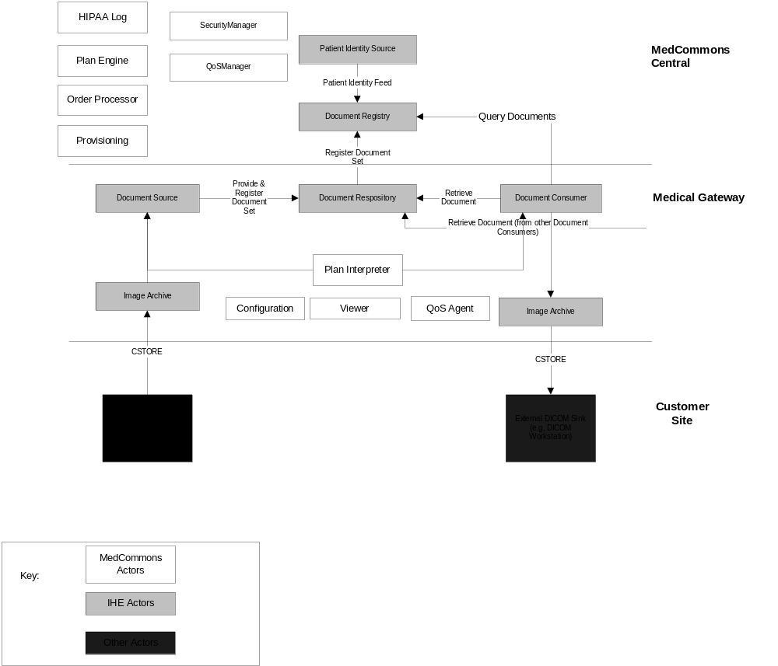
Figure 2: Actors in the MedCommons System: Case of DICOM Images

Actors in MedCommons (Gateway)

Actor | Description
Image Archive (IHE) | A system that provides long term storage of evidence objects such as  images, presentation states, Key Image Notes and Evidence Documents.
Document Source (IHE) | The Document Source actor is the producer and publisher of documents. It is responsible for putting documents into a Document Repository actor. It also supplies meta-data to the Document Repository Actor for subsequent registration of the documents with the Document Registry actor.
Document Repository (IHE) | The Document Repository actor persistently stores documents. It assigns and maintains a unique identifier for each document, to allow Document Consumers to retrieve them.
Document Consumer (IHE) | The Document Consumer Actor queries a Document Registry Actor for documents meeting certain criteria, and retrieves selected documents from one or more Document Repository actors.
Plan Interpreter | Execute plans obtained from central server.  A command language is needed for the plan steps.  Transactions are initiated by the Plan Interpreter from inputs from the Order Processor. The meta-data supplied to the Document Repository is determined by the Order.
Viewer | Creates Web representation of documents on gateway.  WADO viewer is special case.
Document Importer | Accepts documents and meta-data from external source. Digests input into format acceptable to the Document Source actor.  In the case of DICOM objects files are written in part 10 format as input to the Document Source
Document Exporter | Transmits documents and meta-data to external consumer. Translates into format acceptable to the External Consumer.  For the case of DICOM images the files from the Document Consumer are in DICOM Part 10 format; these objects are CSTOREd to the External Consumer.
QoS Agent | Measures quality of service; provides MIB. Also provides mechanism for collecting error messages on gateway (DICOM, machine utilization, network connectivity, &etc).
Configuration | Stores configuration information; communicates with the Provisioning agent for configuration information and updates.

IHE Actors in MedCommons (Central)

Actor Name | Description
Security Manager | A general subsystem for handling security. TBD  Includes some components of the IHE Audit Record Repository actor:  A system unit that receives and collects audit records from multiple systems.  The audit trail contains information so that questions can be answered such as:  For some user: which patients’ PHI was accessed  For some patient PHI: which users accessed it  What user authentication failures were reported  What node authentication failures were reported
QoS Manager | Aggregates data from QoS Agents running on gateways. The QoS Agents can’t be directly polled by the QoS manager (firewall restrictions); the QoS Agents need to call the QoS manager to provide information.  This manager will need to be mildly sophisticated; an alert may need to be generated if (for example) a QoS agent hasn’t checked in recently.
Patient Identity Source (IHE) | The Patient Identity Source actor assigns a unique identifier to each instance of a patient as well as maintains a collection of identity traits.
Document Registry (IHE) | The Document Registry actor maintains meta-data about each registered document in a document entry. This includes a link to the Document Repository where the actual document is stored. The Document Registry responds to queries from Document Consumer actors about documents meeting specific criteria. It also enforces some healthcare specific technical policies at the time of document registration.
HIPAA Log | Manages the HIPAA log entries and queries.
Plan Engine | Creates plans from orders and other information. Plans are executed by the Plan Interpreter actor on the gateways
Order Processor | This actor processes MedCommons Orders, not IHE ones. A MedCommons Order is both a contract with the customer to provide certain services and a document that specifies (perhaps implicitly) the actions required by the contract and the security constraints applied during contract execution. IHE orders are not part of the platform for version 1.0. MedCommons Orders submitted by Affiliates both control the scope of platform actions and define all security relationships between patients and clinicians.
Provisioning | Provisioning is defined broadly here to encompass installation/downloads/configuration of software as well as creation and management of user accounts.

Other IHE Actors
Actor | Location | Description
Acquisition Modality (IHE) | Customer site. This is the device which generates the image data. | A system that acquires and creates medical images while a patient is present, e.g. a Computed Tomography scanner or Nuclear Medicine camera. A modality may also create other evidence objects such as Grayscale Softcopy  Presentation States for the consistent viewing of images or Evidence Documents containing measurements.
Image Display | Customer site | DICOM workstation

Objects in the MedCommons Universe

Persons
Patients and Doctors are both instances of person. Person objects contain only enough information to support authentication. Affiliates may have their own Person objects with more information needed for their business models but all Patients in their universes must be registered in the MedCommons universe.

MedCommons Orders

A MedCommons Order has two conceptual pieces. The first is the business transaction portion (the Business Order): it contains fields for tracking numbers, date of order, and carries enough status state that the progress of the order can be seen on a control screen in the system. Enough information on the destination is extracted from the CCR (see below) to route the Order to the correct location. This part of the order contains no PHI; thus access by support personnel need not generate entries to the HIPAA log.
The second piece is a small document containing the clinical information in the transaction. This document is a Continuity of Care Record (CCR) encoded in XML. The CCR contains all patient information (health status, history, documentation of care, insurance information, care history, care plan recommendations).

The Business Order is a parameter in web service calls; storage of its contents may be transient. The CCR document is placed in the repository and has the same retention rules as other documents.

Documents
Documents include images (typically DICOM but may include JPG and PNG), CDA (XML documents defined by HL7 – including the CCR schema definitions), PDF files, and any ASCII or XML format defined with Affiliates. We envision that the number of formats will grow over time.

Nodes
There are a number of different nodes in the MedCommons Architecture
- Gateways
- Affiliate Applications
- Central Site
- Customer devices (workstations, modalities)

The first three of these communicate securely using certificates issued by MedCommons. The customer device interaction currently takes place behind firewalls – no certificates are required for the first version of the platform.

Affiliate Interfaces

MedCommons Affiliates have the following broad roles:

Affiliates provide the public face for customer interaction – both doctors and patients, including provisioning services, user registration, configuration of authorization roles. user authentication, first tier support for customers and launching the WebTop/WADO viewer in the correct context.

Affiliates handle the order processing. This includes the interface for selecting the items referred to in the order: image data and other primary data objects, services (second opinion, CAD, etc), notifications (self, doctors, …). This is completely in the control of the Affiliate which takes an approved order form, fills in the details, and lets the user (explicitly or implicitly) sign the form. A singular Web Service Call activates the order processing facilities within MedCommons Central.

Affiliates operate a call center to support their customers directly. MedCommons provides a number of screens and Web Service APIs to help facilitate their functions.

Affiliates manage the provisioning process. MedCommons may have a provisioning API – but the management of when provisioning happens at a customer site is managed by the Affiliate (outside of the trivial cases of automatic updates – the configuration of which is done by the Affiliate)

Annotated IHE example

The following example is copied verbatim from the XDS specification
http://www.rsna.org/IHE/tf/IHE_ITI_Cross-enterprise_Doc_Sharing_PC_2004-06-15.pdf
Although this is a cardiac example the DICOM and XDS transactions are identical to many other clinical use cases. Footnote annotations are used to describe Affiliate transactions within MedCommons.

10.3 Integration Profile Process Flow
A typical patient goes through a sequence of encounters in different Care Settings. In each care setting, the resulting patient information is created and managed by multiple care delivery systems (EHR-CRs). Through a sequence of care delivery activities, a number of clinical documents are created. The EHR-LR provides the means to share the relevant subset of these documents, as they are contributed by the various EHR-CRs that are part of the same clinical affinity domain.

Cardiac Patient Management Scenario
This scenario spans about 3 weeks of a patient’s cardiac episode. The patient presents to her primary care provider (PCP) with complaints of shortness of breath, nausea, tiredness and chest pains. This doctor works closely with a local hospital that has recently established a cardiac care network that allows PCPs, cardiologists, laboratories and two local hospitals to share clinical documents to improve patient care.

- 1. Before the patient examination, the PCP queries the cardiac care network for clinical information on the patient over the last two years. He locates a prior ECG report that is retrieved. He performs a new ECG and determines that the patient should be referred to a cardiologist.

Using PCP EMR system, he creates a submission request for a “PCP office visit” that includes a submission set of 3 new documents (visit note, referral letter, new ECG report) and reference to the prior ECG report. In addition, he chooses to create a “cardiac assessment” Folder to contain all four document in order to facilitate collaboration with the cardiologist.
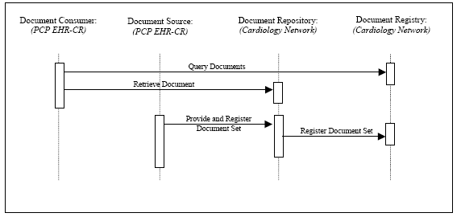

Figure 10.3-1 PCP Query Transactions Process Flow

The PCP EMR system implements the Document Consumer and Document Source Actors to issue the Query, Retrieve and Provide & Register transactions as shown in Figure 1. The transactions are processed by the Document Repository and the Document Registry provided by the cardiology care network.
- 2. The patient appointment with the cardiologist is scheduled. The patient goes to the lab for the lab tests required before appointment. The lab creates a submission set with a clinical code of “laboratory tests” containing the lab results. The lab is not aware of the “cardiology assessment” folder.
- 3. The cardiologist sees the patient. He queries the repository for the patient’s records in reverse chronological order. Available are the Visit note from the PCP, the ECG and prior ECG, the referral letter (all part of the “cardiac assessment” Folder) and the lab results.

The cardiologist performs an ultrasound, dictates a visit note, and orders a nuclear stress test. The visit note and ultrasound images and report are registered as a “cardiologist office visit” submission set and place in the “cardiac assessment” Folder. In addition, the lab report is added to the “cardiac assessment” Folder.
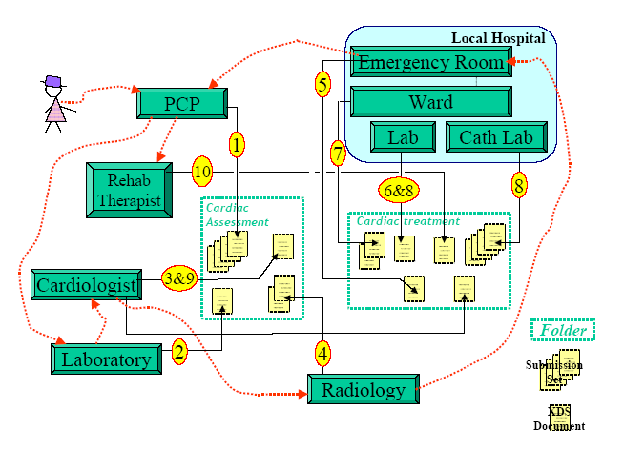
Figure 10.3-2 Cardiac Patient Management Scenario Transaction Process Flow

- 4. The patient is seen at Radiology facility for the nuclear stress test. The test is performed, and the radiologist dictates the report. The nuclear stress test report is registered in a “radiology examination” submission set and associated with the “cardiac assessment” Folder.
- 5. Although she has a scheduled appointment with her cardiologist in two days, she wakes up with severe chest pain. On the way to work, she decides to go to the emergency room (ER) of her local hospital.

The ER doctor uses the Hospital EHR system to queries the cardiac care network registry and repositories for documents related to the patient in reverse chronological order. Available documents from latest cardiology related Folder are the visit notes from PCP and cardiologist, the recent ECG and past ECG, the lab results, and the ultrasound images and report, and the nuclear stress test images and report.
The ER doctor orders lab tests, ECG, and places the patient under monitoring. The lab tests and ECG are placed in the Hospital EHR that acts as a Document Repository Actor for the cardiac network. Abnormal cardiac activity requires a catheterization diagnostics and possibly intervention. The ER doctor admits patient to the cardiology service and contacts the Cardiologist.

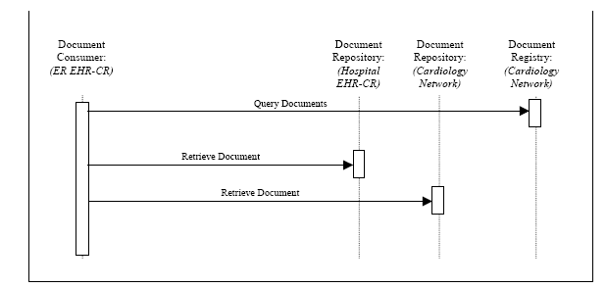
Figure 10.3-3 ER Query Transactions Process Flow
- 6. While talking to the ER physician, the cardiologist accesses the cardiac care network from his home office. He queries for all documents related to the patient since the last visit in his office. The nuclear stress test report that he did not previously review is available, along with Lab results and ECG results from the ER. The two physicians determine a plan of care and the cardiologist makes arrangements to see the patient in the hospital.
- 7. The ER visit notes are submitted as an “emergency department visit” submission set and placed in a newly created “cardiology treatment” Folder along with the earlier lab and ECG results.
- 8. The patient is transferred to an inpatient bed with the following sequence of events.
- • The patient is scheduled for a catheterization procedure in cath lab.
- • Additional lab tests are ordered and performed.
- • A diagnostics procedure is performed in cath lab.
- • An intervention with the placement of a stent is performed.
- • A cath intervention report is dictated.
• Patient is returned to monitored care for recovery.
• Education given to patient and family.
• Discharge Summary dictated by cardiologist.
• Cardiologist orders lab tests to be completed prior to scheduled follow-up visit.

The Admission Assessment, Lab results, Cath intervention report and key images, and Discharge Summary form a “cardiology intervention” submission set, which is registered with the cardiac care network registry for the “cardiac treatment” Folder.
- 9. The patient returns to the cardiologist for the post discharge follow-up visit. The result visit note, cardiac rehab and summary letters are placed in a “cardiology office visit” submission set and in the “cardiac treatment” Folder.
- 10. The patient goes to rehab sessions as scheduled by the cardiologist. The patient recovers and is seen by the PCP and Cardiologist for routine visits.

One or both Gateways (and the enterprise firewall in front of it) must be willing to accept incoming connections on port 80 (or another designated port) in order for a direct transfer to succeed.
Although HL7 is a fundamental protocol the platform largely ignores it at present . HL7 2.x is currently a clumsy ASCII protocol which is defined over a socket connection; HL7 3.0 is an XML-based protocol which will probably use ebXML as the transport.
The DICOM protocol has many parts that will be used in future versions of MedCommons – including worklist management, image presentation, digital signatures, and more. The platform currently provides DICOM services for image transmission (CSTORE), query/retrieve, and echo.
If there are multiple ways protocols for doing the same thing – which do we do first? The ones that make a sale or a good demo.
For a possible HIMSS 2005 demonstration some non-image data might be added to XDS (this would fit into the ‘Other Document Sources’ box)
Note that for the case of DICOM images that the Document Import/Export actors have been replaced by the more specialized Image Archive actor – which is an IHE actor.
From the customer’s point of view this may be seamless – but the integration of services is happening in the customer’s browser window. Image (and other documents imported into MedCommons) are displayed by the viewer but the selection of the order, authentication, and authorization are handled by the Affiliate.
Need to adjudicate billing/order disputes. May need access to MedCommons transactions for this or MedCommons needs to push data to the Affiliate site as billable/supportable transactions occur.
From the OpenSPLM site: Service provisioning refers to the "preparation beforehand" of IT systems' materials or supplies required to carry out a specific activity. It goes beyond the initial "contingency" of providing resources, to encompass the entire lifecycle management of these resources. This includes the provisioning of digital services such as user accounts and access privileges on systems, networks and applications, as well as the provisioning of non-digital or "physical" resources such as cell phones and credit cards.
With MedCommons some of the infrastructure is changed although the transactions may appear to be the same from the point of view of some of the customers. Three affiliates are used in the example below: a PCPAffiliate, a CardiacAffiliate and a LabAffiliate. These could all be the same company – but with MedCommons they need not be.
In this example the first IHE step (#1) is that the PCP queries for earlier studies. In MedCommons the first actions steps are that the patient is registered with MedCommons and that permissions were granted to the PCP to perform queries. Patient permission is mediated by the Affiliate. MedCommons will not release patient information submitted through one Affiliate to another Affiliate without an order form executed by the patient. No PCP access to patient records is permitted without a patient’s permission; that permission is granted by an order. The PCPAffiliate provides both the interface for generating the order for doctor access and the interface for the doctor to access the patient’s account.
All of the interactions for managing documents (creating a folder, creating a submission set, adding documents to submission sets or to folders) are parts of XDS. The MedCommons Gateway is performing the roles of Document Registry and Document Repository (see Figure 1 earlier in this document). Software for the Document Source/Document Consumer may be provided by MedCommons for some types of documents (e.g., DICOM images) or by the Affiliate. So – the Affiliate may push (or help the customer push) documents to the Gateway via DICOM, XDS, or other protocols supported by the Gateway. These documents are then available as input for Orders.
Using MedCommons the CardiacAffiliate gets permission from the patient to view their information via the order submitted by the PCPAffiliate.
The LabAffiliate adds new records to MedCommons but is probably not able to view any other patient information (depending on the order). The order and security mechanisms make it possible for an Affiliate like the LabAffiliate to submit documents (e.g., be a Document Source Actor) without being able to read them (e.g., be a Document Consumer actor). In the IHE scenario above the Lab is not aware of the ‘cardiology assessment’ folder; in MedCommons this is a feature. There may be no reason for the LabAffiliate to have this access.
The CardiacAffiliate provides access to the cardiologist for all patient records as specified by the PCPAffiliate Order.
The CardiacAffiliate permits the cardiologist (or his staff) to perform this operation. Access for adding folders and documents was in the original order submitted by the PCPAffiliate.
This is the MedCommons registry via the CardiacAffilate’s interface.
Although coordinated and memorialized in HIPAA business associate contracts, the privacy policies of MedCommons and the Affiliates are separate. Depending on the Affiliate, the patient has granted the PCP and the cardiologist long term access to her records via the original order forms. MedCommons does not centrally manage access permissions for anyone other than the patient. The patient can also access all of this data from their home as well as access the HIPAA Log to see who has seen their records. Depending on the Affiliate, the patient can also remove the PCP and the cardiologist’s access at any time.

